**INTRODUCTION TO ROBOTICS**

**Lab Report 3**

**Name of members:**

**NC** Muhammad Saqib

**Submitted to**: LE Hamza Sohail

**Velocity Control**

**Code:**

function sysCall_init()

sim = require('sim')

prismaticJoint = sim.getObjectHandle('Prismatic_joint')

Velocity = 0.3

-- do some initialization here

end

function sysCall_actuation()

sim.setJointTargetVelocity(prismaticJoint, Velocity)

end

function sysCall_sensing()

-- put your sensing code here

end

**Simulation:**

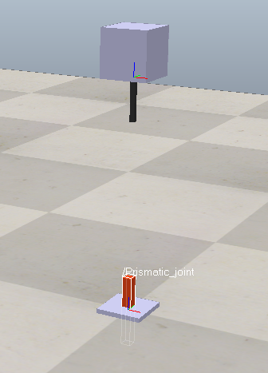

Figure 1

**Position Control**

**Code:**

function sysCall_init()

sim = require('sim')

prismaticJoint = sim.getObjectHandle('Prismatic_joint')

Position = 0.25

-- do some initialization here

end

function sysCall_actuation()

sim.setJointTargetPosition(prismaticJoint, Position)

end

**Simulation:**

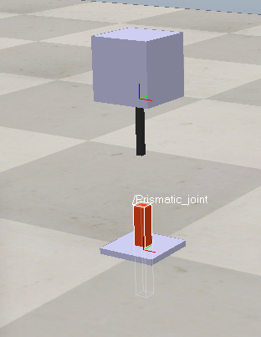

Figure 2

**Observations:**

* Under **velocity control**, the attached cuboid maintained a constant, steady-state linear speed, accurately reflecting the configured target velocity.
* Under **position control**, the cuboid executed a smooth trajectory to the commanded target position, achieving precise endpoint stabilization without overshoot or steady-state error.
* The system demonstrated a direct and predictable relationship between input parameters and output motion: increasing the target velocity parameter resulted in a higher translational speed, while increasing the target position parameter resulted in a greater linear displacement.
* The controller exhibited stable and linear performance throughout testing, with no observable oscillations, instabilities, or non-linear artifacts.

**Conclusion**:

This laboratory exercise successfully demonstrated the implementation and performance of velocity and position control for a prismatic joint actuating a cuboid load. The control strategies were validated, with velocity control enabling consistent linear motion and position control ensuring accurate terminal positioning. The established experimental setup and control architecture provide a foundational framework that can be extended to more complex multi-joint robotic systems and advanced control tasks.